1. Run **eeglab** from MATLAB Command Window  
     
   **Collect data files → convert files to CSV → convert CSV files to EDF  
    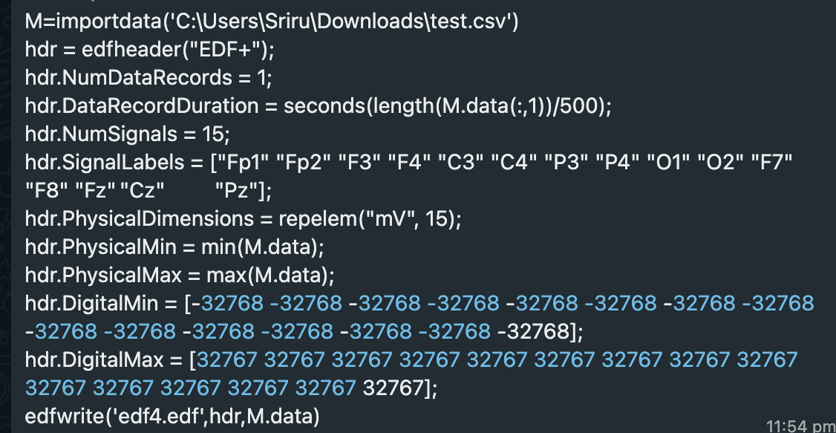**
2. **Opening an Existing Dataset:  
   File → Import Data → Using EEGLAB functions and plugins → From EDF Files   
   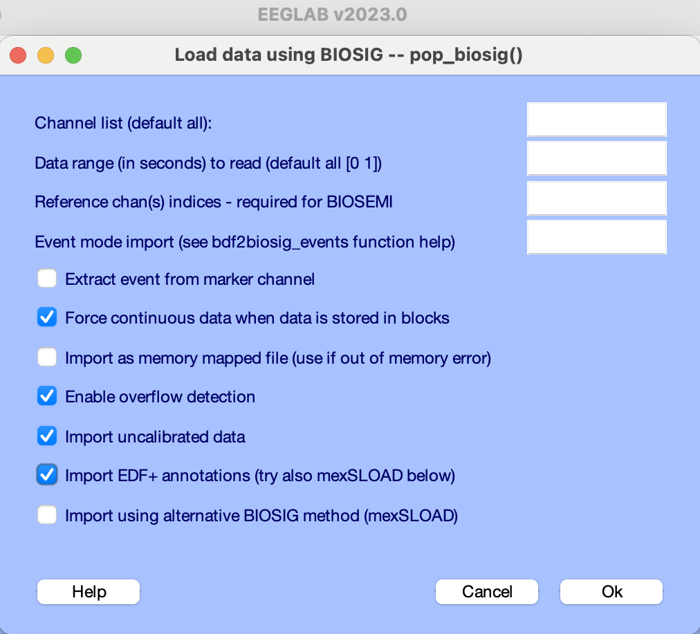**
3. **Editing Event Fields:  
   File → Import event info → From MATLAB array or ASCII file   
     
   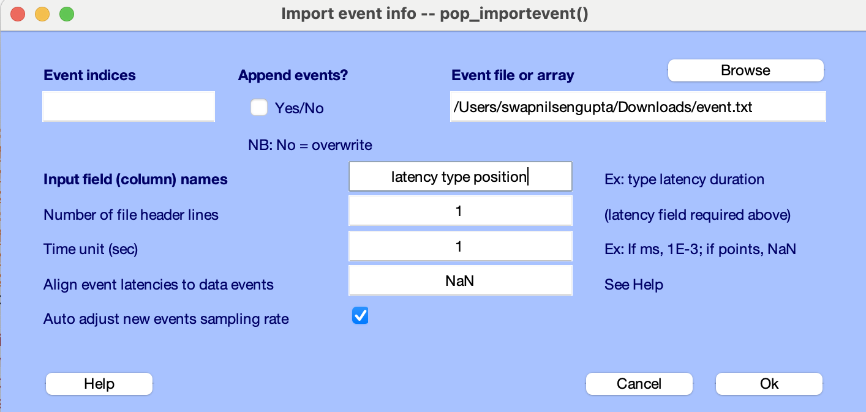  
     
   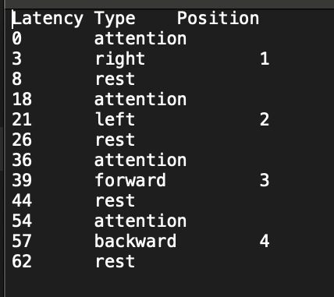**
4. **Edit → Channel locations  
     
   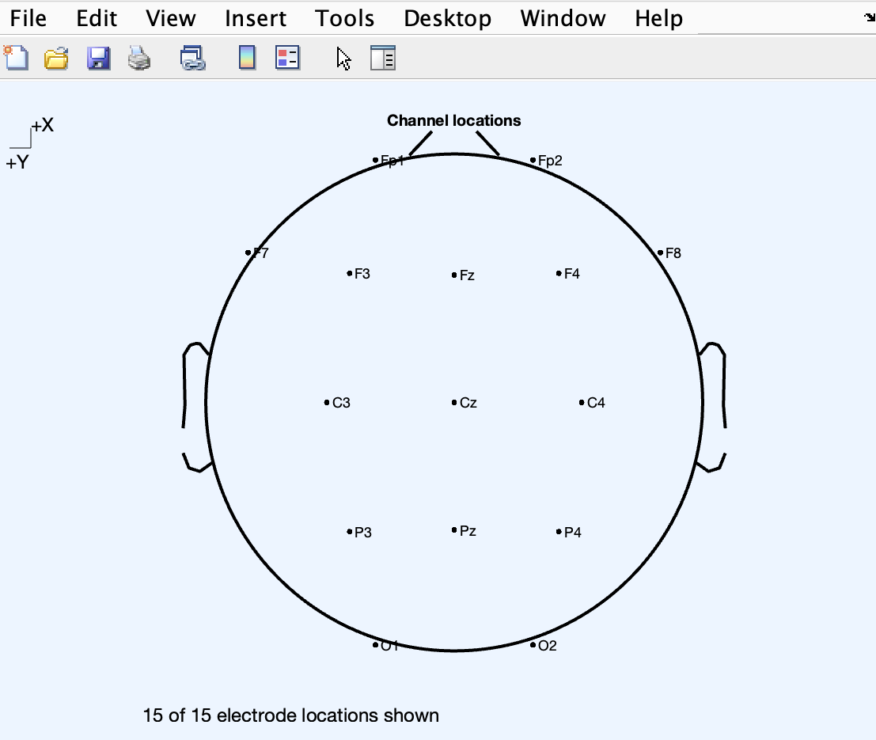  
     
   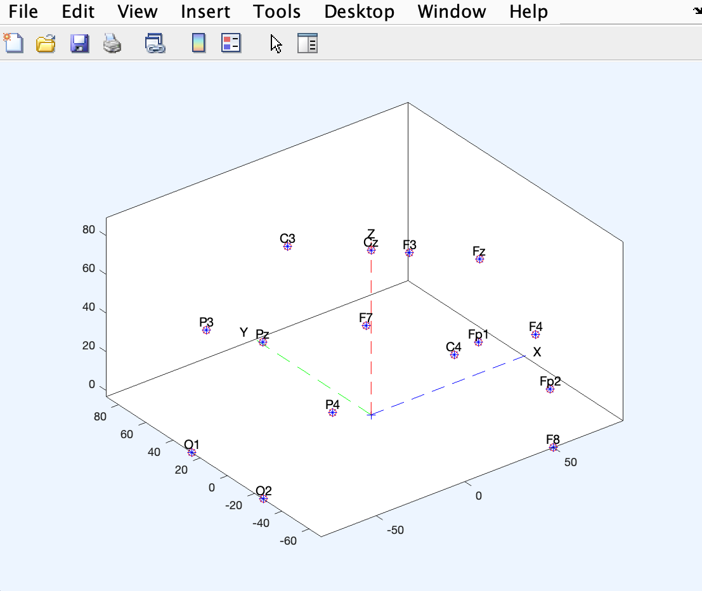**
5. **Plotting Channel Spectra and Maps:  
     
   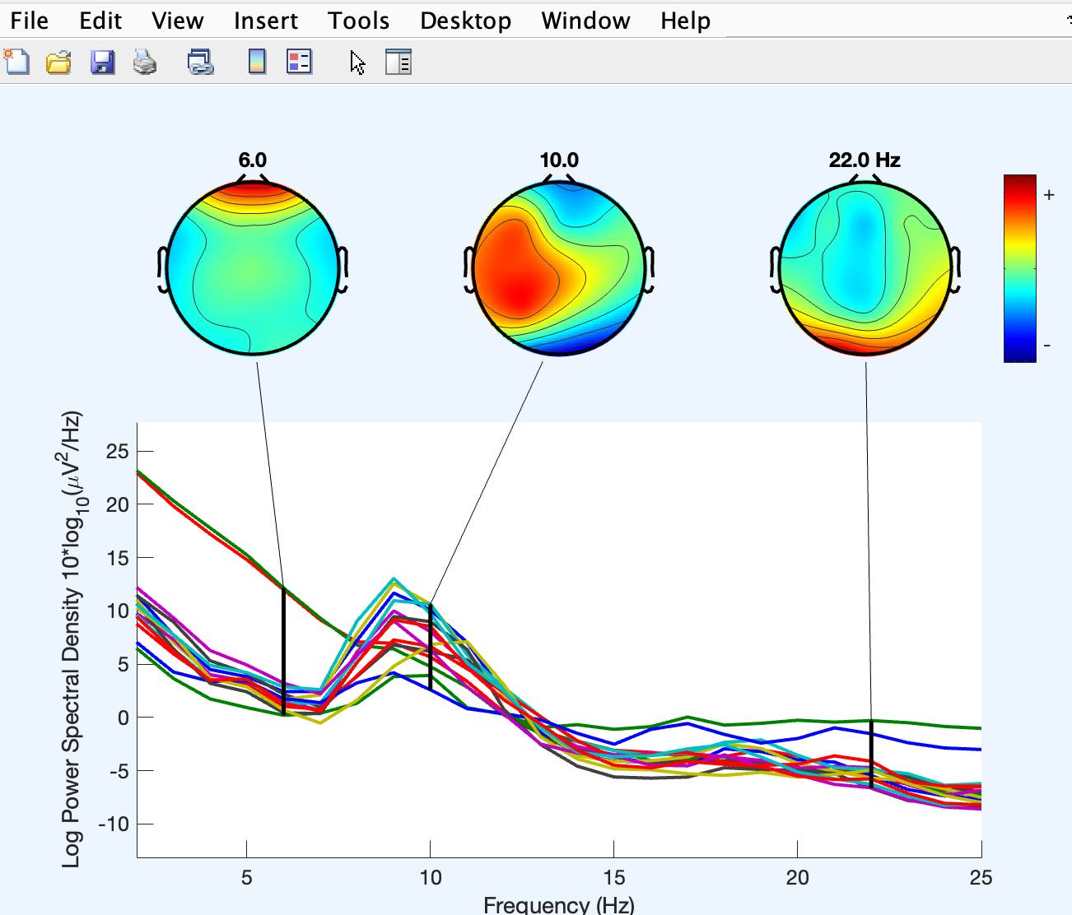**
6. **Extracting data epochs:  
     
   Tools → Extract epochs  
     
   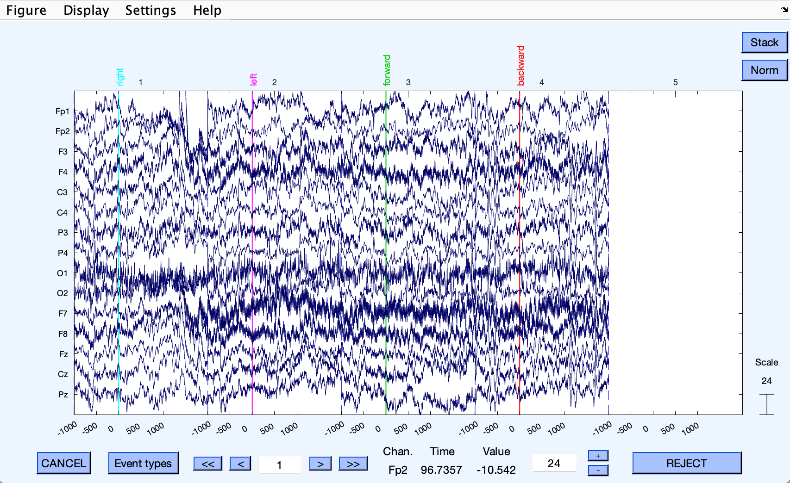**
7. **Plotting the ERP data on a single axis with scalp maps:  
     
   Plot → Channel ERP Image  
     
   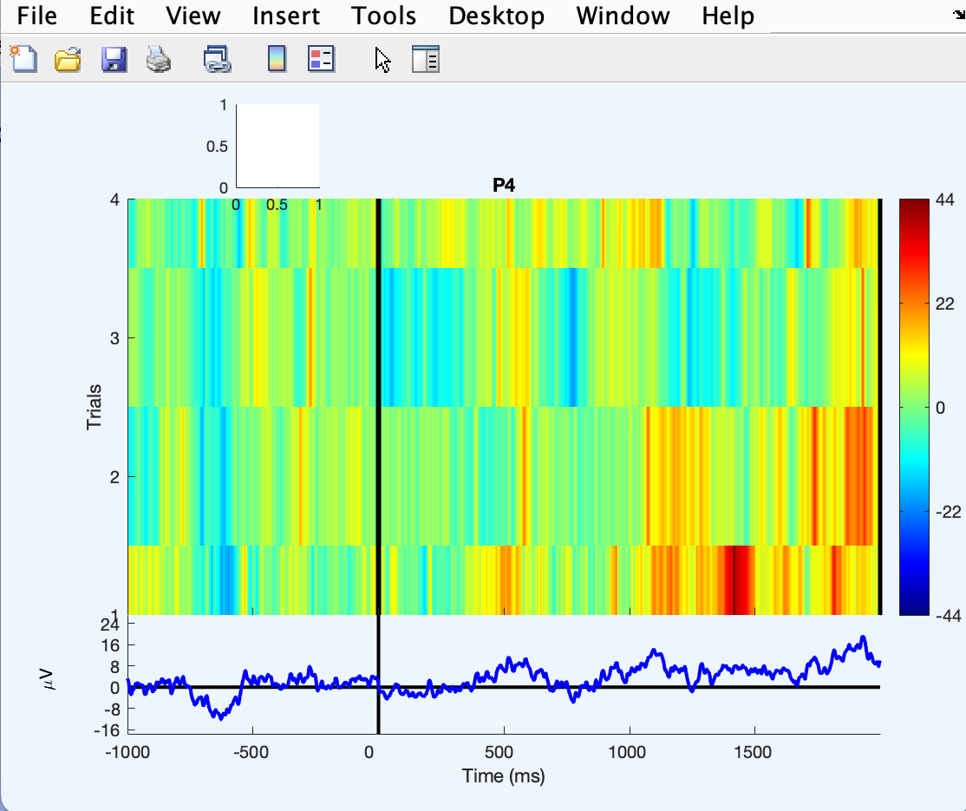**
8. **Plotting ERP traces in a topographic array:  
     
   Plot → Channel ERPs → In scalp/rect. Array   
     
   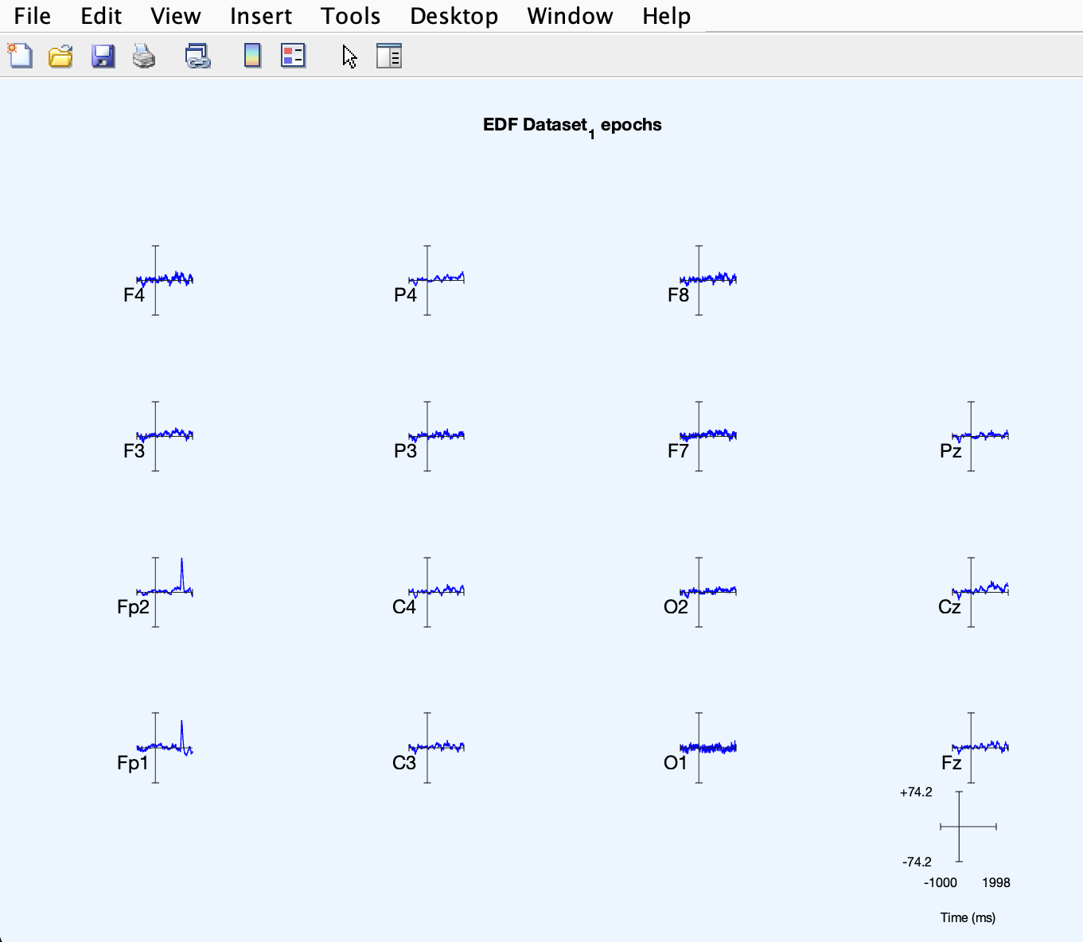  
     
   Plot in rect. array  
     
   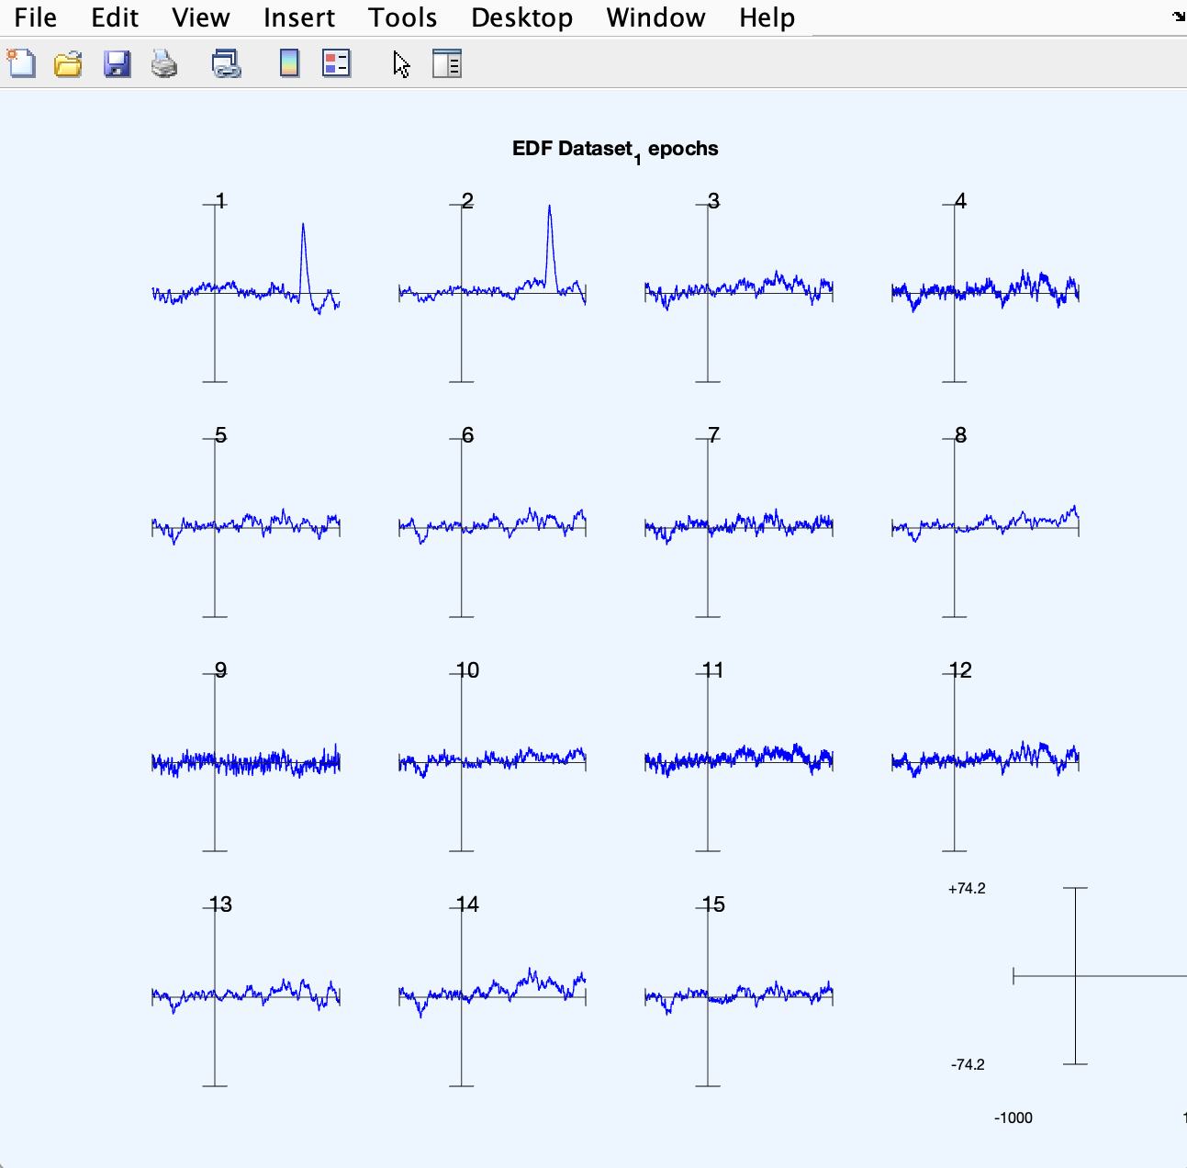**
9. **Plotting an ERP as a series of maps:  
     
   Plot → ERP Map Series → In 2D  
     
   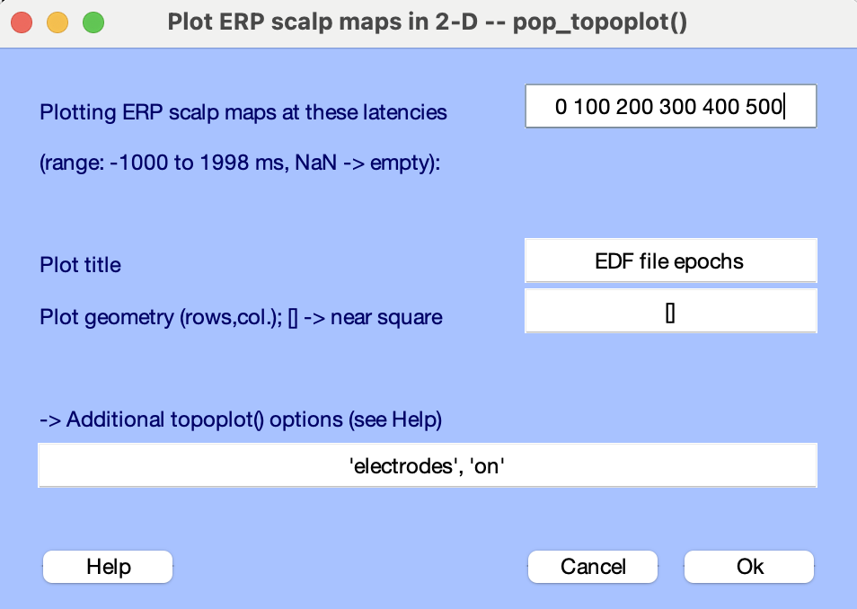  
     
   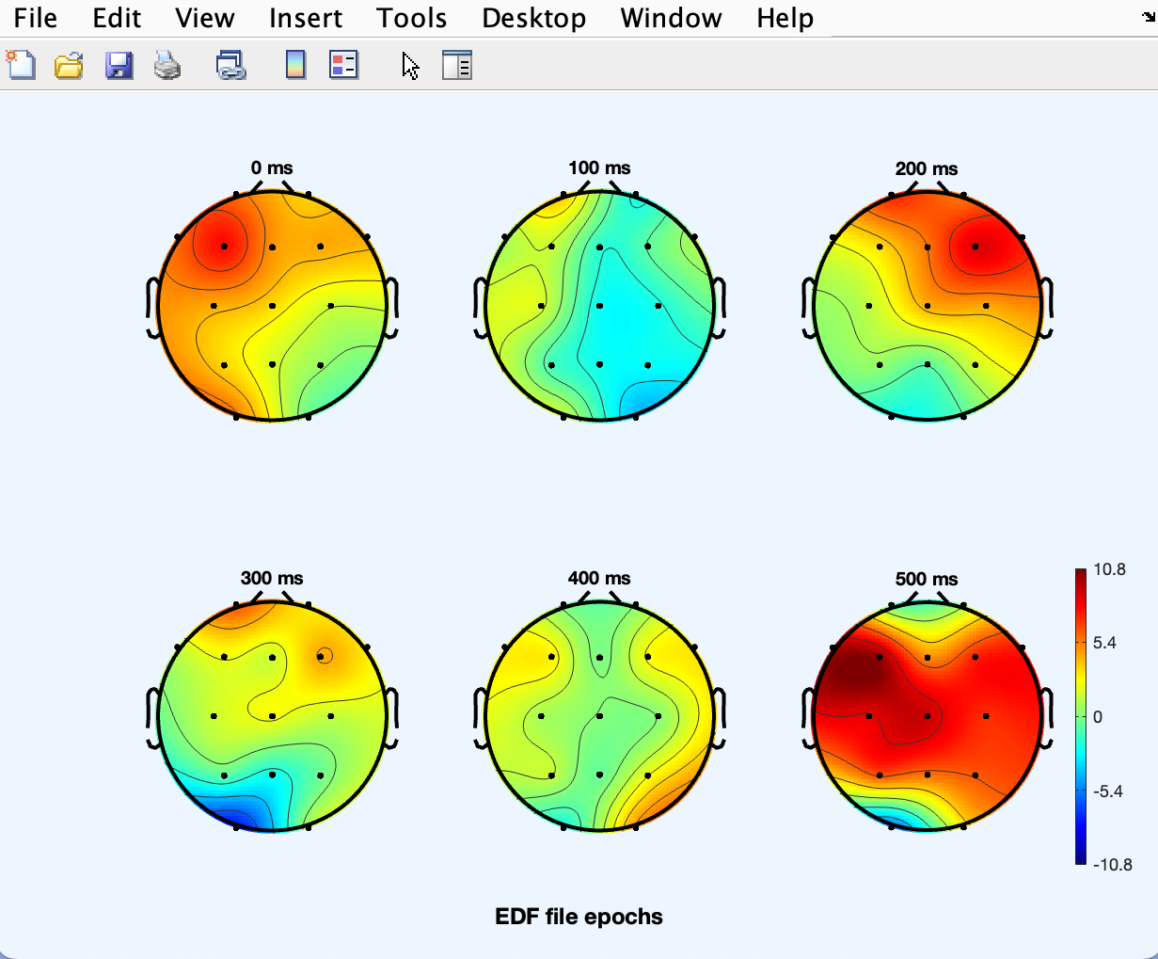  
     
   Plot → ERP Map Series → In 3D  
     
   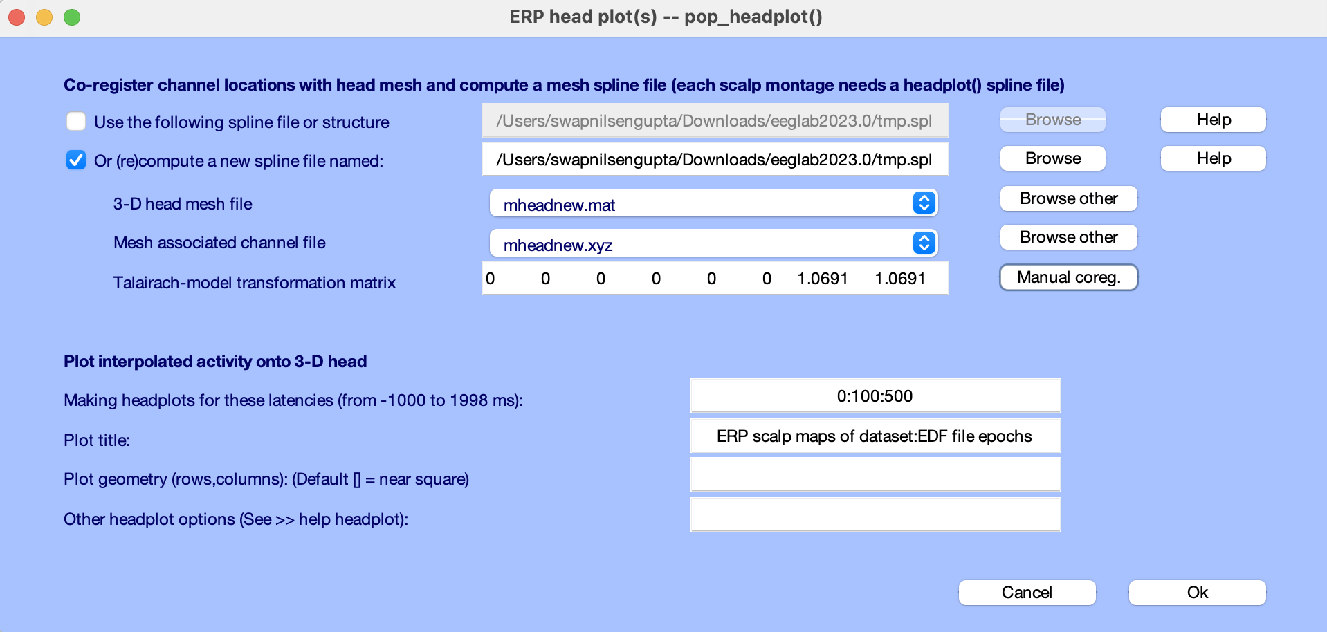  
     
   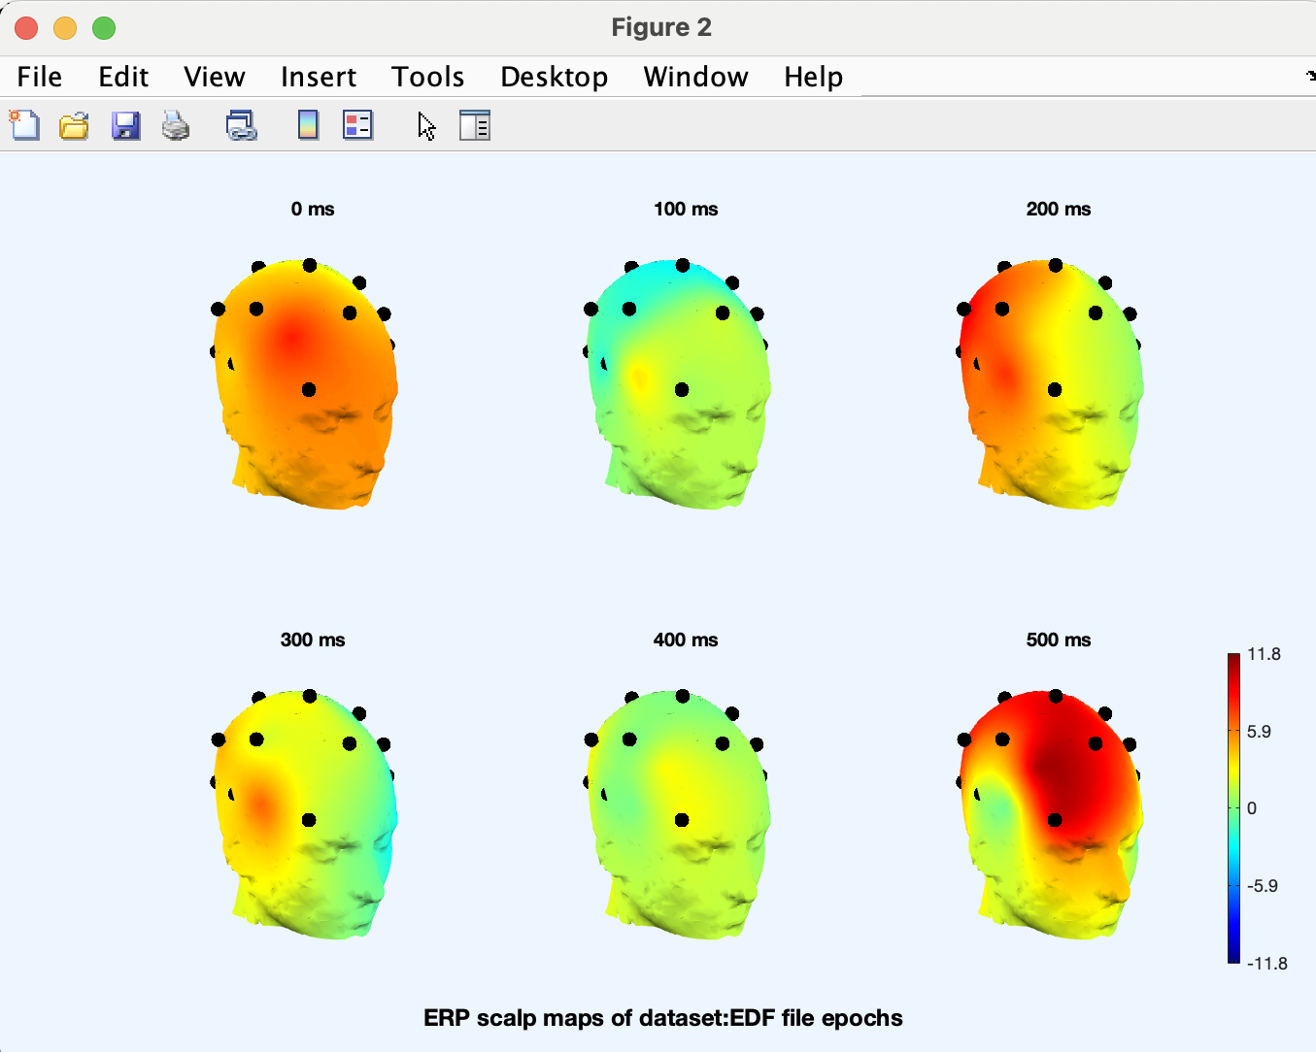**
10. **Plotting ERP images using pop_erpimage():  
      
    Plot → Channel ERP image  
      
    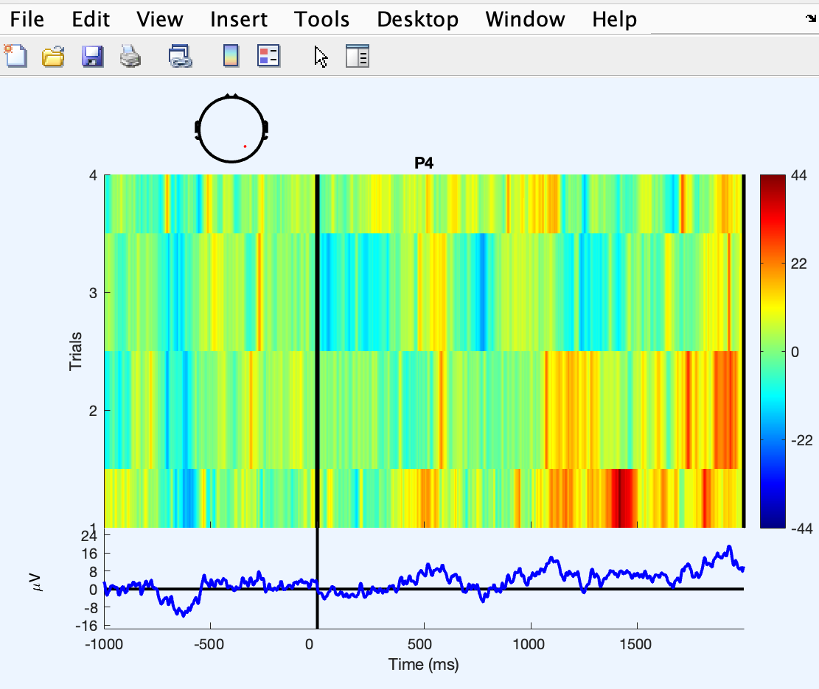**
11. **Sorting trials in ERP images:  
      
    Too few trials.**
12. **Running ICA decompositions:  
      
    Tools → Decompose data by ICA  
      
    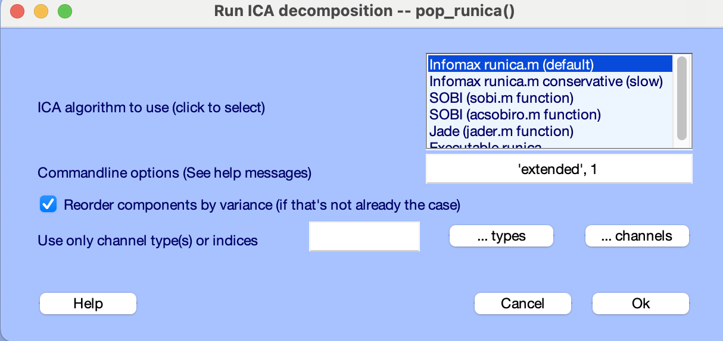**
13. **Plotting 2−D Component Scalp Maps:  
      
    Plot → Component Maps → In 2D  
      
    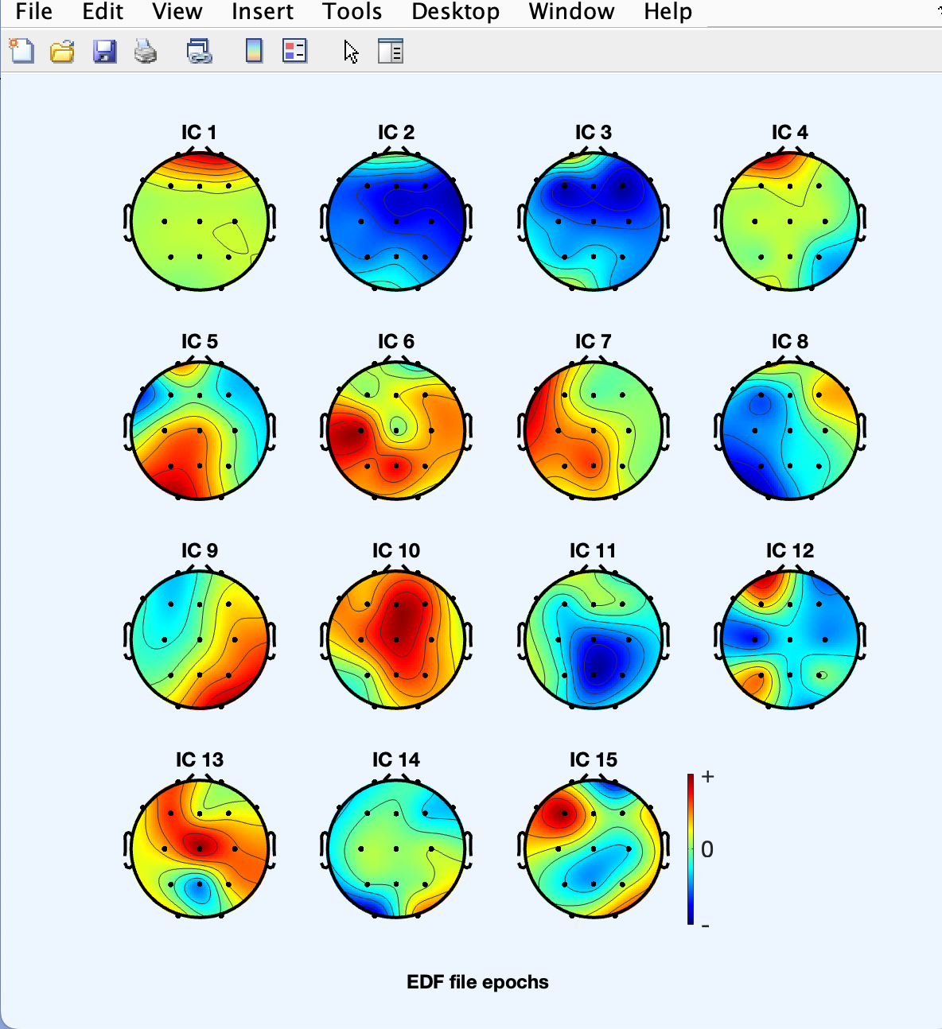  
      
    Plot → Component activations (scroll)   
      
    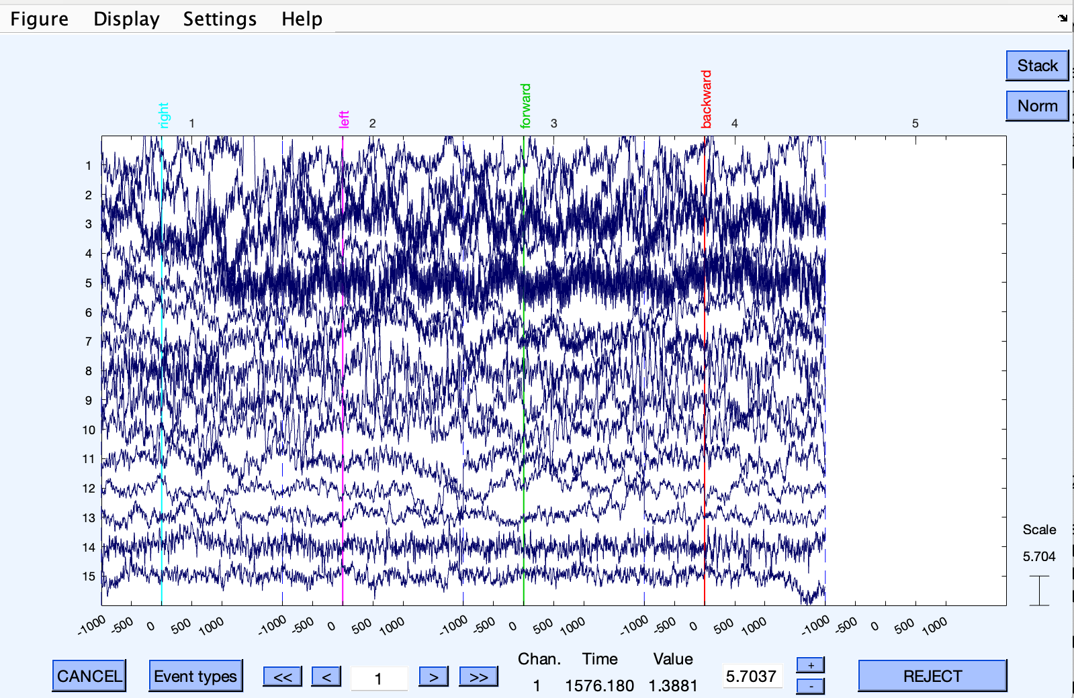**
14. **Plotting component headplots:  
      
    Plot → Component maps → In 3D  
      
    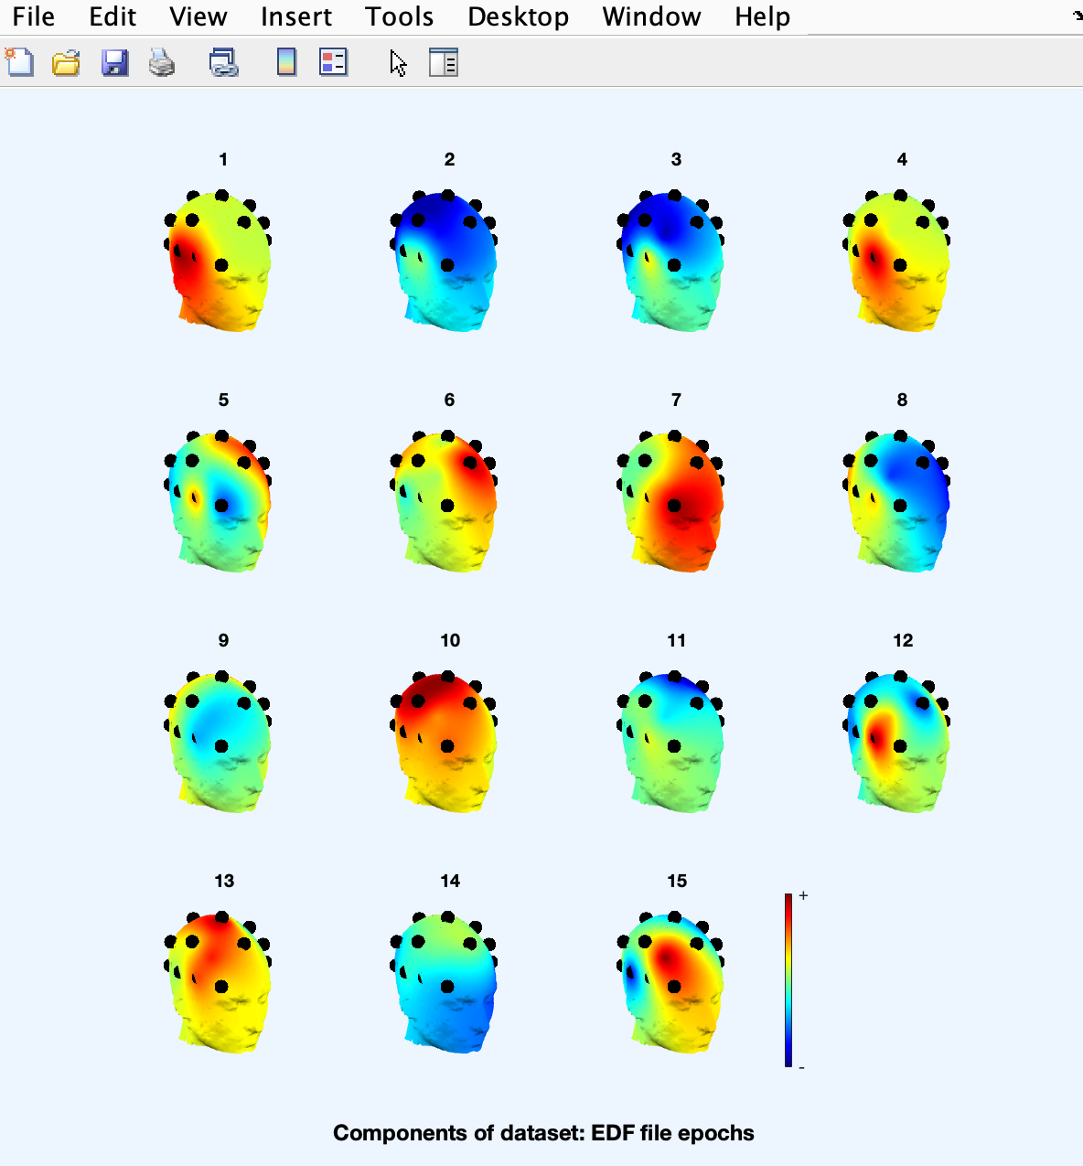**
15. **Studying and removing ICA components:  
      
    Tools → Remove components from data  
      
    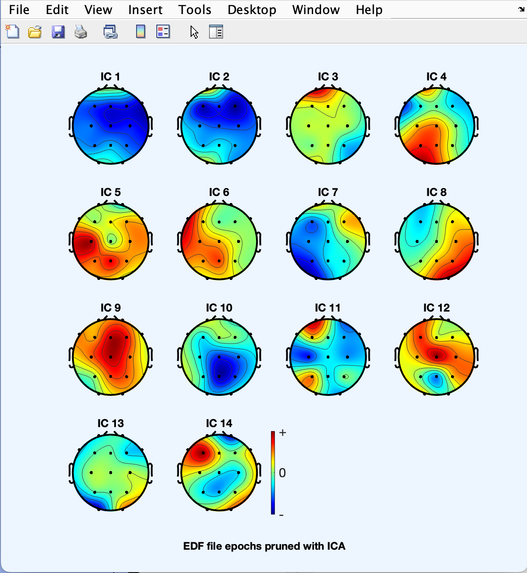  
      
    Plot → Component activations (scroll)  
      
    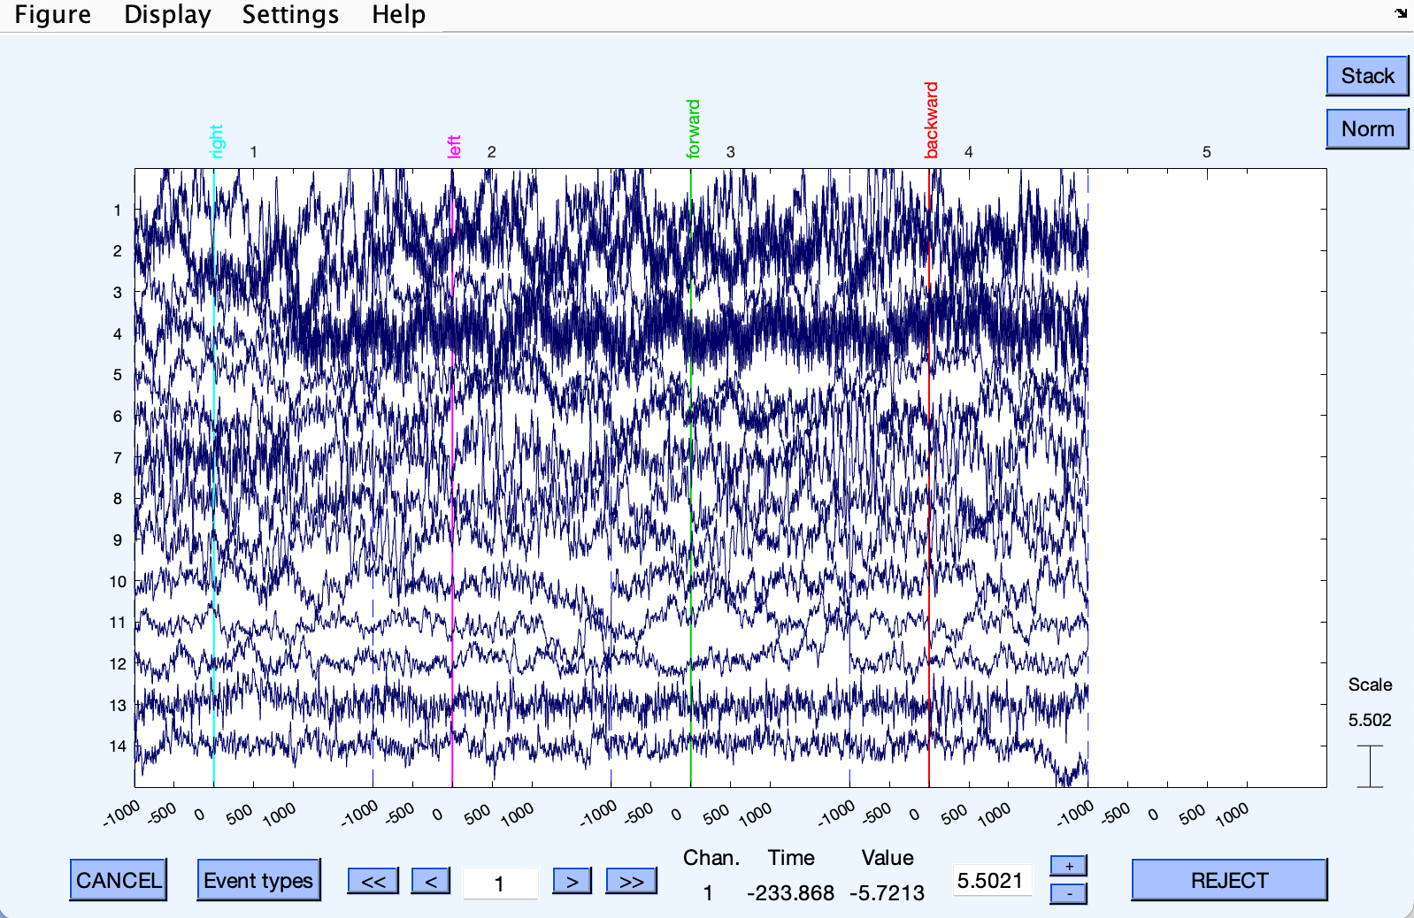  
      
    Plot → Component properties  
      
    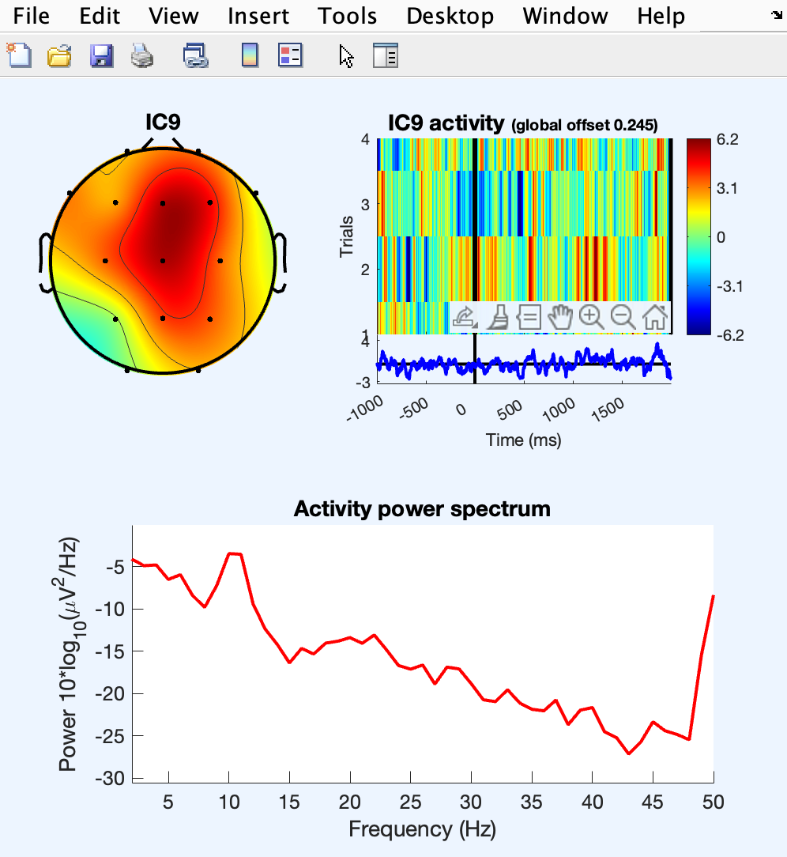  
      
    Channel data (scroll)  
      
    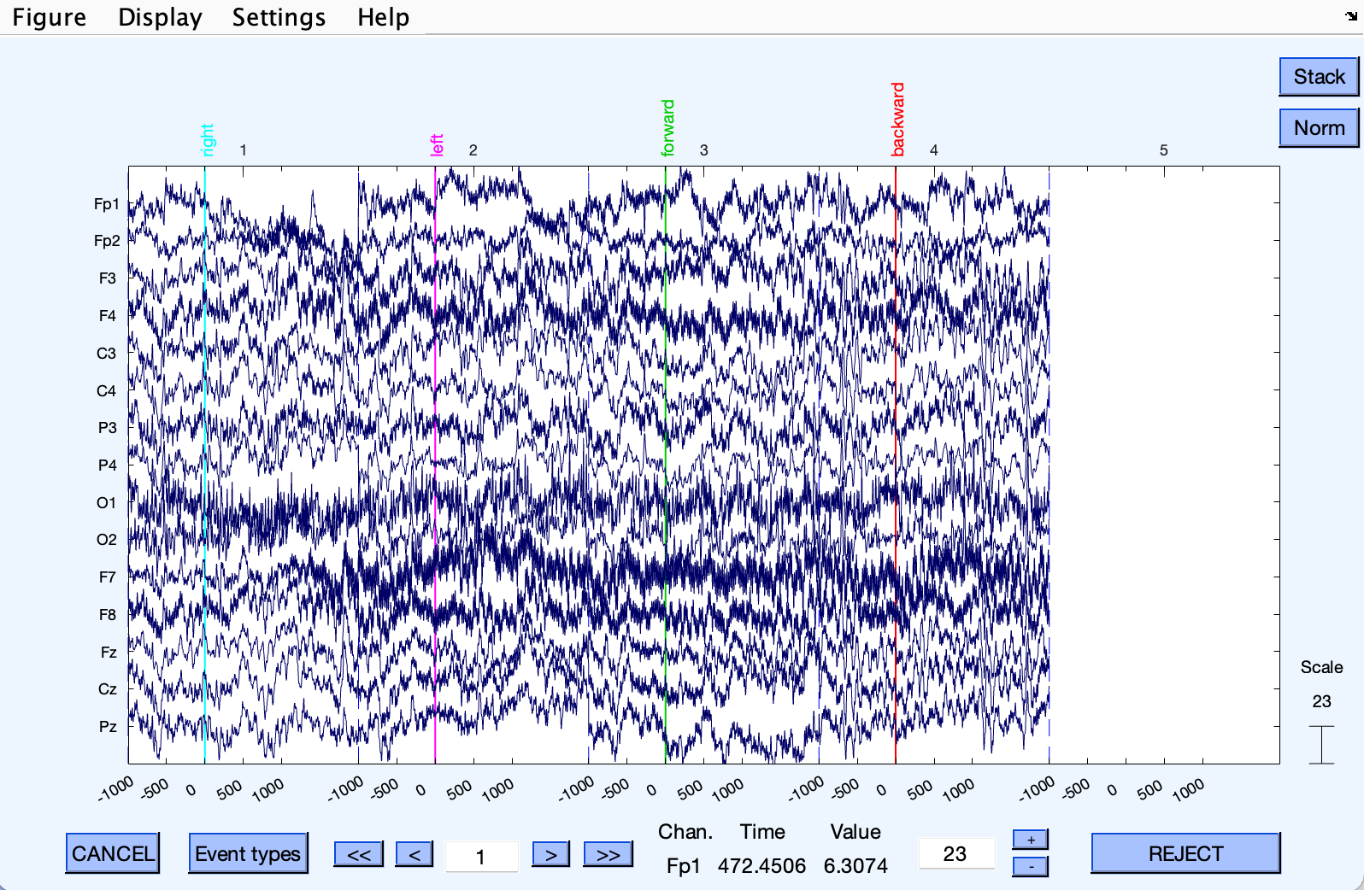**
16. **Plotting component spectra and maps:  
      
    Plot → Component spectra and maps  
      
    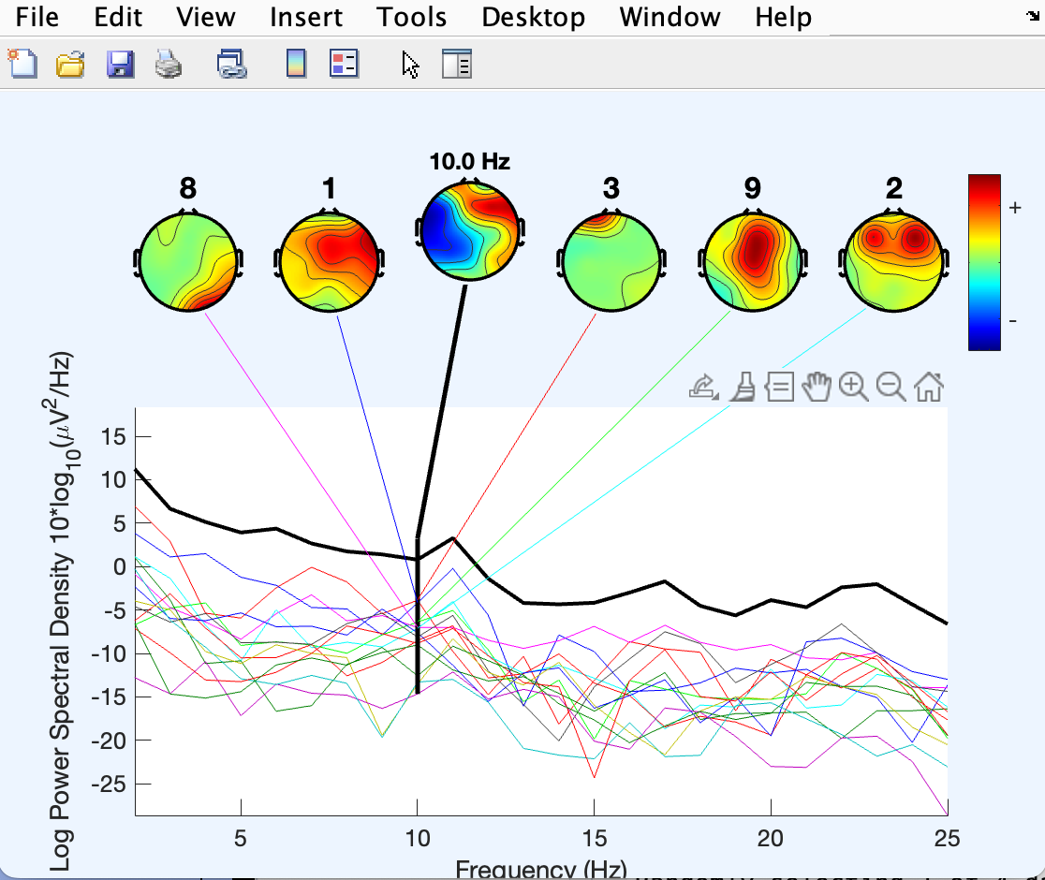  
      
    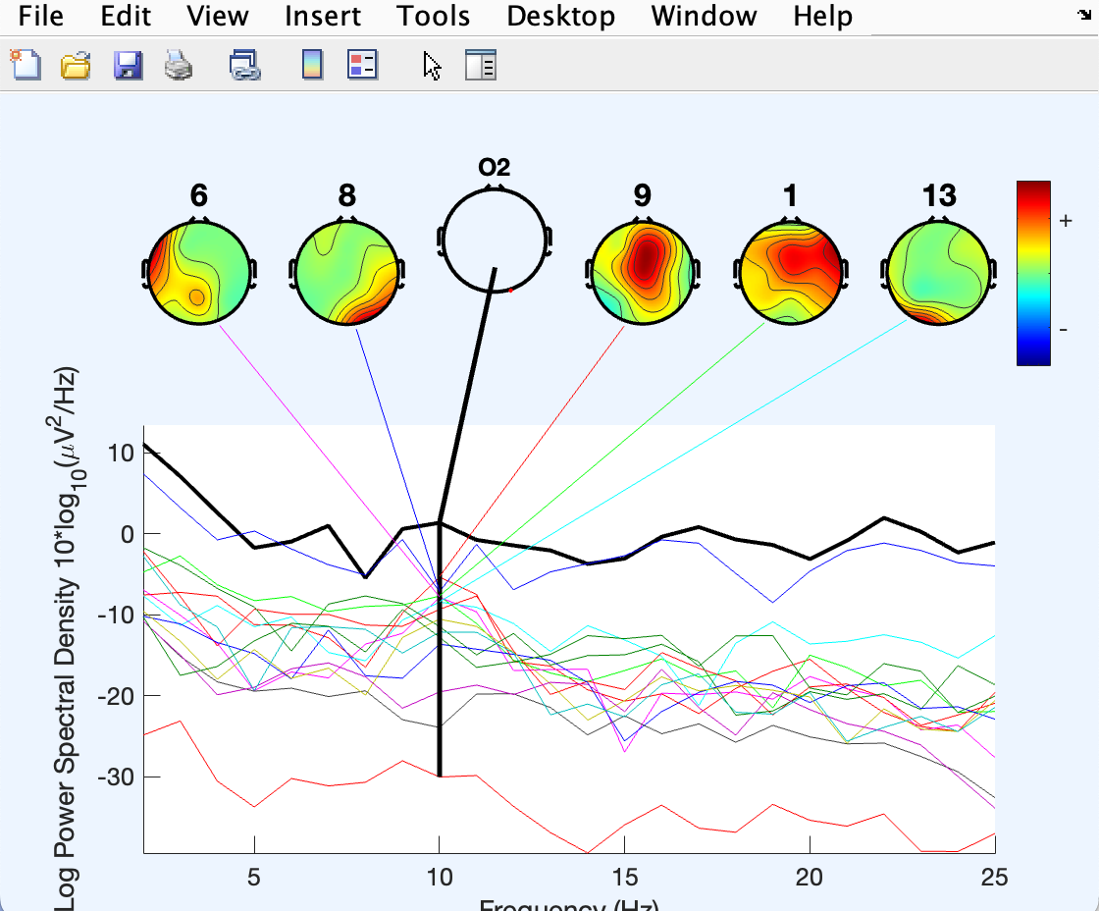**
17. **Plotting component ERPs:  
      
    Plot → Component ERPs → In rectangular array  
      
    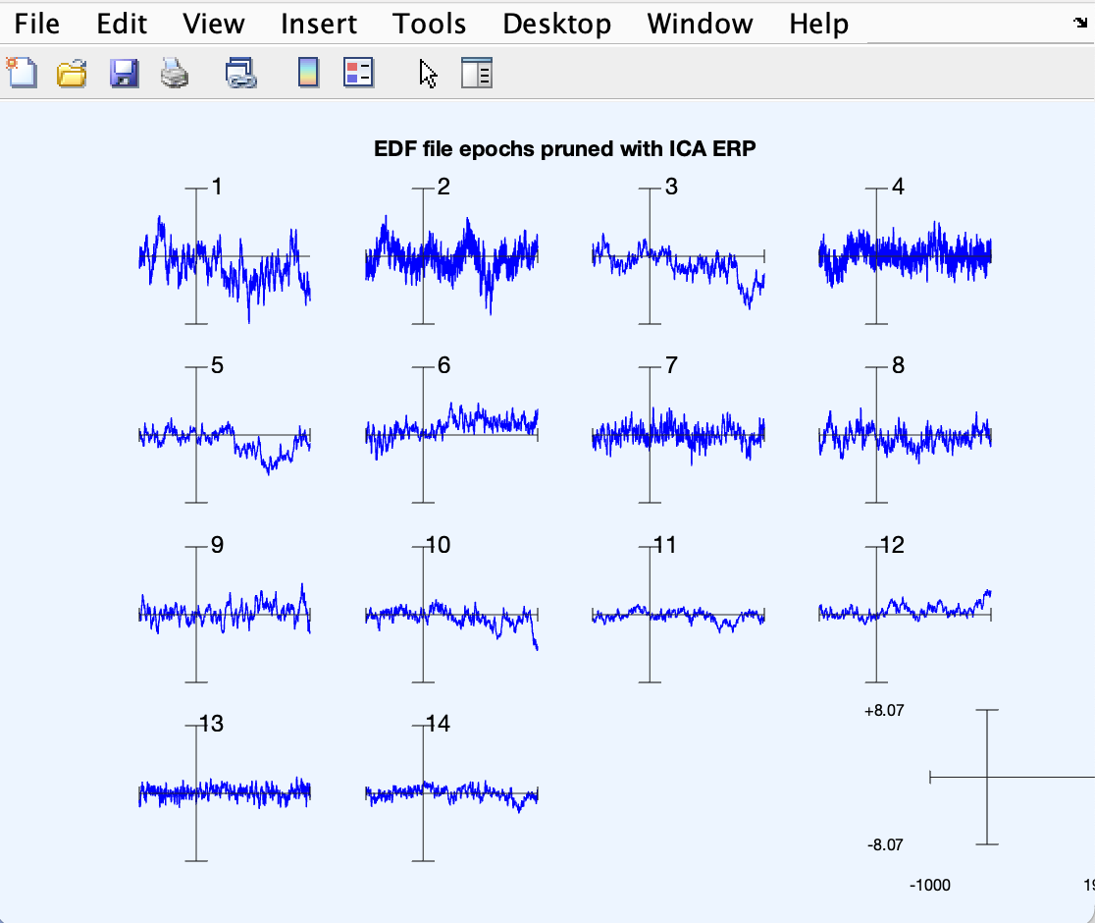**
18. **Time/Frequency Decomposition, Decomposing channel data:  
      
    Plot → Component time-frequency  
      
    